**INDIAN INSTITUTE OF TECHNOLOGY, BOMBAY**

**Department of Mechanical Engineering**

ME119 – Engineering Drawing and Graphics 2020-21 Semester I

Sheet 7: Orthographic Projections

|  |
| --- |
| **Instructions:**   * Practice all problems in rough before coming to the Drawing Session. * Solve these problems on A4 sized sheets as instructed during the lecture. * You can refer to the recommended textbook for relevant material to help you solve these problems. * Make the title block and name plate on each A4 sheet for before starting the drawing for each problem as shown in the course instructions (Lecture 0). * All labelling must be in block (capital) letters as displayed in the instructions with proper letter size. * The geometrical construction lines should be light as compared to the main figure lines. * Scale and dimension the drawings suitably. Label the important nodes/points on the drawings. Mention the scale next to the drawing if it is not 1:1 (Just write SCALE 1:2 etc. for reducing scale and SCALE 2:1 etc. for enlarging scale). * **This sheet will be graded.** You will be given marks based on the **correctness, neatness, labelling, border, name plate** etc. of your submitted work showing your understanding of the concepts. These marks will count towards your final course grade. * If the completed sheet is not submitted within the lab session time, it will result in zero marks being allotted to that lab session. |

**Friday Lab Session**

1. Figure shows the FV and RHSV of an object. Draw the TV. You will have to draw all the three views on your sheet for the sheet to be complete. Follow all the drawing conventions meticulously and dimension your drawing properly. All dimensions are in mm.

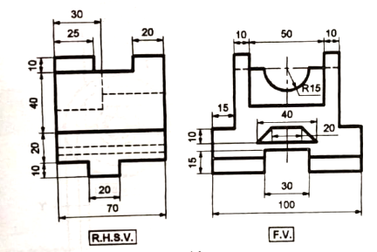

1. Pictorial view of an object is shown. Draw the FV, TV and LHSV. Front view corresponds to the appearance of the object when viewed along the direction X of the arrow shown in the figure. Follow all the drawing conventions meticulously and dimension your drawing properly. All dimensions are in mm.

